Exercise 9
- List the minimum perks package.
Answer: SELECT MIN(perks) AS minimum_perks
FROM employee_data;
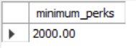

- List the maximum salary given to a "Programmer".
Answer: SELECT MAX(salary) AS max_programmer_salary
FROM employee_data
WHERE title LIKE '%Programmer%';
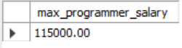

- Display the age of the oldest "Marketing Executive".
Answer: SELECT MAX(age) AS oldest_marketing_executive_age
FROM employee_data
WHERE title = 'Marketing Executive';
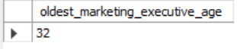

- (Tricky!) Find the first and last names of the oldest employee.
Answer: SELECT f_name, l_name, age
FROM employee_data
ORDER BY age DESC
LIMIT 1;
